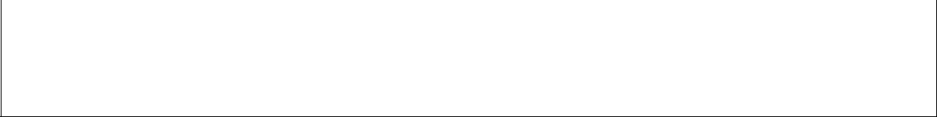
 | Mahammad Isayev | 3. assignment/3. Task |  |  | 19th May 2021 a

VF36R7
vf36r7@inf.elte.hu
Group 1

Task 3

Layers of gases are given, with certain type (ozone, oxygen, carbon dioxide) and thickness, affected by atmospheric variables (thunderstorm, sunshine, other effects). When a part of one layer changes into another layer due to an athmospheric variable, the newly transformed layer ascends and engrosses the first identical type of layer of gases over it. In case there is no identical layer above, it creates a new layer on the top of the atmosphere. In the following we declare, how the different types of layers react to the different variables by changing their type and thickness.
No layer can have a thickness less than 0.5 km, unless it ascends to the identical-type upper layer. In case there is no identical one, the layer perishes.

 | thunderstorm | sunshine | other
ozone | - | - | 5% turns to oxygen
oxygen | 50% turns to ozone | 5% turns to ozone | 10% turns to carbon dioxide
carbon dioxide | - | 5% turns to oxygen | -

The program reads data from a text file. The first line of the file contains a single integer N indicating the number of layers. Each of the following N lines contains the attributes of a layer separated by spaces: type and thickness. The type is identified by a character: Z – ozone, X – oxygen, C – carbon dioxide. The last line of the file represents the atmospheric variables in the form of a sequence of characters: T – thunderstorm, S – sunshine, O – others. In case the simulation is over, it continues from the beginning.

The program should continue the simulation until one gas component totally perishes from the atmosphere. The program should print all attributes of the layers by simulation rounds! The program should continue the simulation until one gas component totally perishes from the atmosphere. The program should print all attributes of the layers by simulation rounds!

The program should ask for a filename, then print the content of the input file. You can assume that the input file is correct. Sample input:
4
Z 5
X 0.8
C 3
X 4
OOOOSSTSSOO

Plan¹

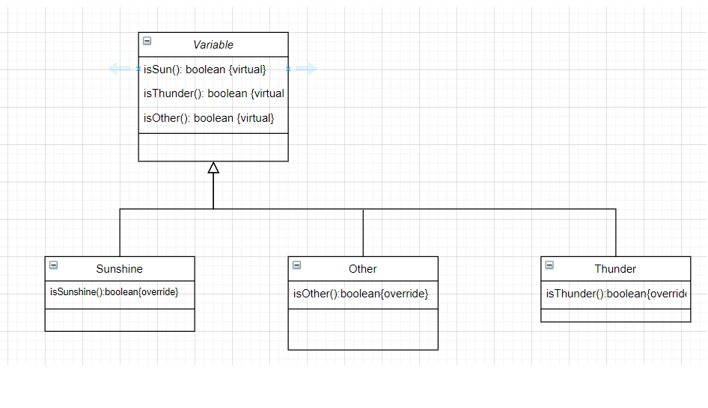
To describe the layers 4 classes are created: base class Layer to describe the general properties and 3 children classes for the specific layer types: Oxygen, Ozone, CO2. Regardless the type of the layers, they have several common properties like the thickness(_thickness), the getter for the thickness(get_Thickness()), boolean method (perish())which checks whether the layer has perished or not, and method which changes the thickness of the layer (change ()), print method which prints layer’s type and thickness, getID() method which return the ID of the layer(1 for Oxygen, 3 for Carbon, and 2 for Ozone), change() method which returns newly created layer and takes atmospheric variable as parameter, and constructor as well as destructor. The operations: get_Thickness(), perish(), and changeThickness() can be implemented in base class. However, all the rest are going to be abstract methods and hence, the base class Layer is going to be abstract. General description of the atmospheric variables is done in class base Variable. Three other classes: Other, Sunshine, and Thunder will inherit from Variable. The class variable will have three virtual methods: isThunder(), isSun(), isOther() which will return false. And virtual destructor. Three children classes will override respective methods only: class Other will modify only the method isOther().We use singleton design pattern as we do not have to instantiate objects of classes Other, Sunshine, and Thunder with repetition.

- Plain text explanation is not necessary for the student documentations

Simulation_process

A: layers: Layer[m], vars: Variable[n]
Pre = layers = layers’ and vars = vars’
Post = vars = vars’ and layers = ⊕ <newLayer> = <layers[j]->change(vars[i])>
j=0..m i=0..n
We have some cases:
If in the above layers of the current layer, exists identical layer to newly transformed layer, add newly transformed layer’s thickness to the identical layer’s thickness above.
If in the above layers of the current layer, there is no identical layer to newly transformed layer, we check if its thickness is greater than 0.5 (newLayer->perish())
If the current layer’s thickness is less than 0.5 (layers[j]->perish()), then we delete this current layer.

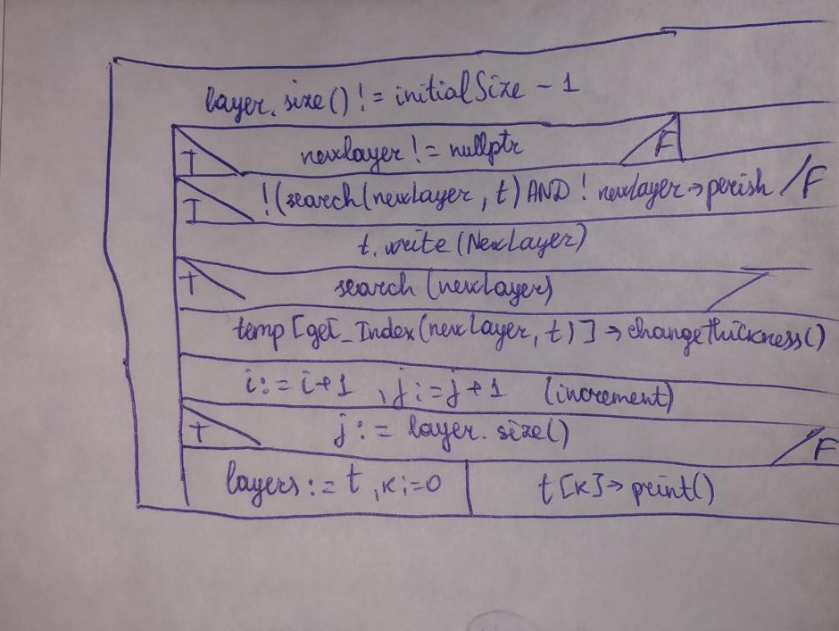

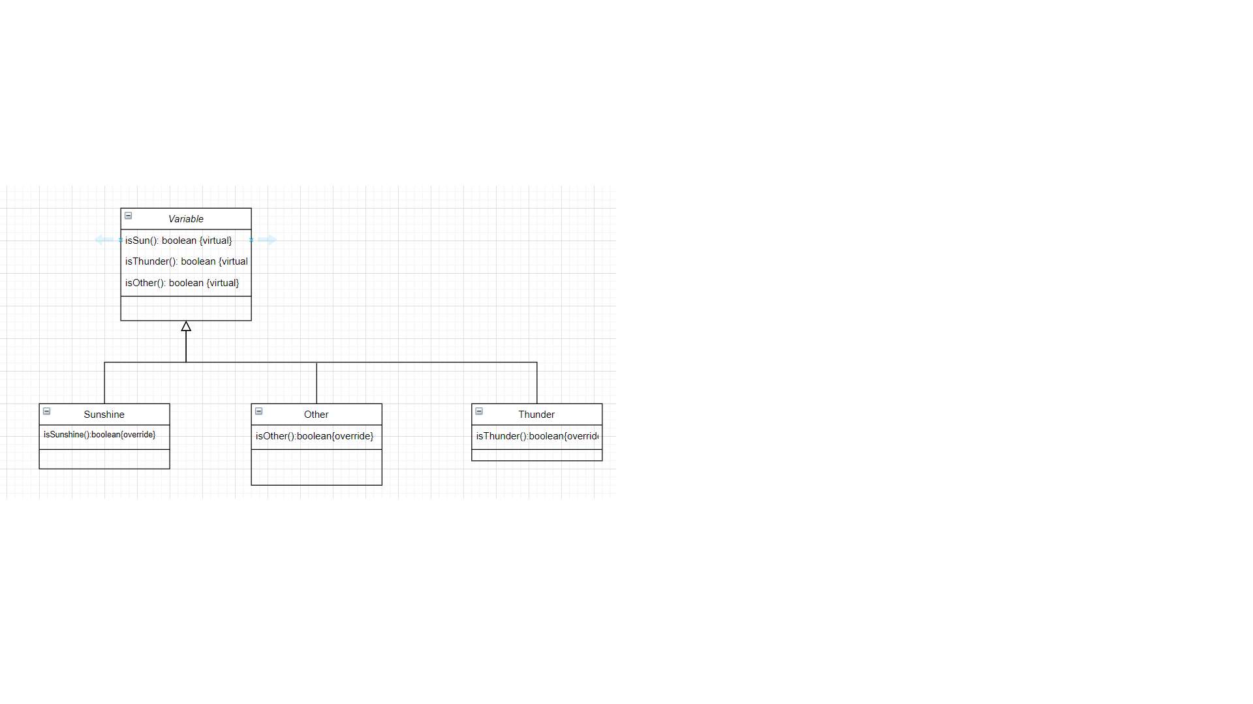

Testing

Testing:
Length-based test

- 4 layer case, i.e. the layers size is initially 4 and in the end it becomes 3
- Many layers case, the layers size is initially 10 and in the end it becomes 9.

